Name: ________________________ Date:__________
Lab 8 - SMALL-SCALE LAB
Precipitation Reactions: Formation of Solids
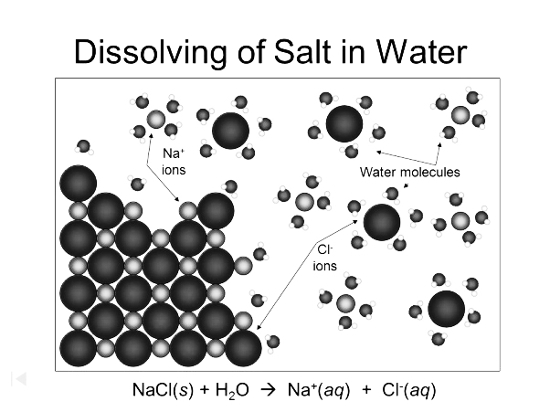
BACKGROUND - When one substance dissolves in another, a solution is formed. A solution is a homogeneous mixture in which the components are uniformly mixed. A solution consists of solute (the species that is dissolved) and solvent (the medium in which the solute has dissolved). The solvent is usually present in larger amount than the solute. When water is the solvent, the solution is called an aqueous (“aq”) solution.
When an ionic compound dissolves in water, it dissociates into its constituent ions (see figure at left). Such a compound is a strong electrolyte (conducts electricity well in dilute aqueous solutions). For example, when NaCl dissolves in water, it dissociates into separate Na⁺ and Cl⁻ ions. This process occurs as polar water molecules orient themselves around the sodium and chloride ions and pull them free from the solid crystal. Once removed from the solid crystal, the ions remain separated and surrounded or hydrated by water molecules. Therefore, the solution now consists of mostly water, and sodium and chloride ions. For all practical purposes, there are no undissociated NaCl units floating around.
Often, we can mix two ionic solutions together and observe a precipitation reaction, which is simply a chemical reaction that involves the formation of an insoluble product (precipitate, or a solid). While the reactants themselves may be soluble, the products formed are insoluble, and separates out as a solid. We may see this solid as crystals that drop to the bottom of the test tube, or as a cloudy or milky white solution.
PURPOSE - For this lab, you will mix two ionic solutions together, and look for the formation of a precipitate. For those combinations of solutions that do form precipitates, you will then write out balanced chemical equations.
SAFETY – Wear safety glasses and follow standard safety procedures for the laboratory
MATERIALS
Pencil and lab sheet
Solutions as follows:
0.05 M AgNO₃
0.2 M Pb(NO₃)₂
0.5 M CaCl₂
1.0 M Na₂CO₃
0.5 M NaOH
0.2 M Na₂SO₄
1.0 M NaCl
Test tubes and test tube rack
Seven pipettes (one for each chemical)

PROCEDURE
Set up your reagents according to the grid provided:

 | AgNO₃  (Ag⁺) | Pb(NO₃)₂  (Pb²⁺) | CaCl₂  (Ca²⁺)
Na₂CO₃  (CO₃²⁻) | ^{(a)} | ^{(e)} | ^{(i)}
NaOH  (OH) | ^{(b)} | ^{(f)} | ^{(j)}
Na₂SO₄  (SO₄²⁻) | ^{(c)} | ^{(g)} | ^{(k)}
NaCl  (Cl⁻) | ^{(d)} | ^{(h)} | ^{(l)}

1. Place your test tubes in the rack so they represent the 4 x 3 arrangement as seen by the grid. Using a pipette (make sure it’s a different pipette for each reagent – do not contaminate the solutions), drop five to six drops of each reagent in the test tube as shown in the above grid.

2. Record your observations for each solution formed, indicating whether a precipitate formed (as evidenced by cloudiness in the test tube), and the color of the precipitate. If no precipitate forms, indicate “no precipitate,” in the grid.

ANALYSIS
Using the experimental data, record the answers to the following questions below:

 | AgNO₃  (Ag⁺) | Pb(NO₃)₂  (Pb²⁺) | CaCl₂  (Ca²⁺)
Na₂CO₃  (CO₃²⁻) | ^{(a)} | ^{(e)} | ^{(i)}
NaOH  (OH) | ^{(b)} | ^{(f)} | ^{(j)}
Na₂SO₄  (SO₄²⁻) | ^{(c)} | ^{(g)} | ^{(k)}
NaCl  (Cl⁻) | ^{(d)} | ^{(h)} | ^{(l)}

1. In each of the grid spaces above, where a precipitate formed, write the chemical formula for the precipitate (HINT: the sodium ion does not comprise ANY of the precipitates).

2. Translate the following word equations into balance chemical equations and explain how the equations represent what happens in their respective grids:

a. In grid space (a), sodium carbonate reacts with silver nitrate to produce sodium nitrate and solid silver carbonate

b. In grid space (f), sodium hydroxide reacts with lead(II) nitrate to produce sodium nitrate and solid lead(II) hydroxide.

3. Write out a word equation to represent what happens in grid space (j), along with a net ionic equation.

4. What happens in grid space (c)? Which other mixings gave similar results? Is it necessary to write an equation when no reaction occurs? Explain.

5. Write balanced equations for the other precipitation reactions you observed for grid spaces as indicated below:

(b)

(d)

(e)

(g)

(h)

(i)

6. Write balanced net ionic equations for the other precipitation reactions you observed for grid spaces as indicated below:

(b)

(d)

(e)

(g)

(h)

(i)

